Forestry Commission : Forest record No. 52

Price 2s. 0d. net

HOME GROWN ROUNDWOOD
Estimated Industrial Requirements 1965 – 75
Compared with Potential Production
By B. W. HOLTAM, B.Sc.

Forestry Commission

FOREWORD
By Professor H. M. Steven, C.B.E., LL.D.

Chairman, Home Grown Timber Advisory Committee

This paper was prepared by Mr. B. W. Holtam of the Forestry Commission at the request of its Home Grown Timber Advisory Committee as part of its review of the present state of development of the forest industry in Great Britain. The Committee considered that the information it contained would be of interest not only to those engaged in that industry, but also to the wider public that is concerned with social, economic and other questions in rural areas, hence the decision to publish. The paper consists of three parts: Part I deals with softwood, i.e. timber from coniferous species; Part II with hardwood from broad leaved trees; and Part III gives some implications of the data.

It is an opportune time to take stock of the production coming from our woodlands during the next decade or so in relation to the requirements of industries based on it. The fruits of the efforts, made by both private owners and by the Forestry Commission, to build up the timber resources of this country after their depletion to meet essential requirements during two world wars, can be seen in a spectacular increase in the flow of timber from our woodlands. Total production of softwood will more than double between 1965 and 1980. It should be noted that until about 1970 potential output from private woodlands will still exceed that from the Forestry Commission, but thereafter supplies from Commission woodlands will increase more rapidly. A considerable part of the increased production of softwood timber, particularly from the Commission, will consist of small roundwood, as defined in this paper, which comes mainly from thinnings. Thus the importance of industries that can use such timber. Traditionally the mining industry has been the largest single market for home grown softwood. Its consumption is falling steeply, however, and this makes it necessary to consider new markets. Scottish woodlands already supply all the timber required by Scottish mines, but a considerable part of English and Welsh requirements are met by importers. Home production should steadily replace these, and accordingly the National Coal Board should remain the principle single market for home grown softwood for the next five years. By 1970, however, the new and expanded pulpmills will have become the principal market for small roundwood of home grown softwood and increasing supplies will be required also by wood chipboard factories. It is worthy of note that home grown wood, processed by these industries, is producing high quality goods which sell in very competitive markets, which are served by the best of the worlds production.

The hardwood pattern is quite different. Woodlands are predominantly mature and …..mature and many contain low grade produce mainly of oak. These woodlands are almost entirely in private ownership. In recent years about 25% of the sawn hardwood con….. in this country has been home produced. The problem is the utilisation of low grade material, one of the outlets being sawn mining timber.

The pattern of consumption of home grown timber may well change, and certainly more precise estimates of production and consumption will become available, hence the position will be kept under review and revised papers prepared periodically.

Printed in England for Her Majesty’s Stationery Office by James Townsend & Son Ltd., Exeter.
(48534) Wt. 2083/3188 4,000 9/64 Gp. 466

CONTENTS

INTRODUCTION

Part I

SOFTWOOD
Potential Production of Softwood by Forestry Commission and Private Woodlands (from Thinnings and Fellings combined)
Potential Total Production (Small Roundwood and Sawlogs together)
Potential Production of Softwood Small Roundwood
Potential Softwood Sawlog Production
……. Industrial Requirements for Softwood from the Forestry Commission and Private Woodlands
Small Roundwood
Potential Sawlogs

Part II

HARDWOOD
Potential Hardwood Production
Estimated Industrial Requirements for Home Grown Hardwood Roundwood
Estimated Requirements of Hardwood Logs for Conversion to Sawn Timber
Estimated Requirements for Conversion to Sawn Mining Timber
Estimated Requirements for Other Purposes

Part III

…PLICATIONS
Softwoods
Hardwoods
APPENDICES
Estimate of Potential Production of Softwoods in Great Britain: Spruce and other Species, in Forest Years 1965-80. Thinning and Felling combined.
Estimated Industrial Requirements (Excluding Sawmills) of Small Roundwood Softwood only, from Forestry Commission and Private Woodlands in Great Britain, in Forest Years 1965-1975
Estimated Potential Softwood Roundwood Production-Great Britain, in Forest Years 1965-1980
Estimated Potential Production of Softwood Roundwood in Great Britain in Forest Years 1965-1980, Classified by Ownership
Estimated Potential Production of Hardwoods in Great Britain by Forestry Commission, Private Woodlands and Combined
Estimated Industrial Requirements of Hardwood from Private Woodlands in Great Britain and from the Forestry Commission, expressed as Roundwood Equivalent

HOME GROWN ROUNDWOOD
ESTIMATED INDUSTRIAL REQUIREMENTS 1965-75, COMPARED WITH POTENTIAL PRODUCTION

INTRODUCTION

- This paper attempts to compare, in a very broad way, estimated potential home production of roundwood between 1965 and 1980 and estimated industrial requirements for that production between 1965 and 1975 in Great Britain. No attempt is made to deal with the total industrial requirement for timber and timber products, which is met in the main by imports, nor is any attempt made to compare the intrinsic properties or the relative competitive positions of home grown and imported wood. Reference is made to imported wood or timber or to consumption (of home grown and imported) only to present home production in perspective. The essential information is shown in Fig. 1 and in Appendices I to VI.

- Potential production is what the forests are capable of yielding annually under sound management, and does not necessarily mean what it is intended to produce. Given good planning, sound management and healthy market conditions, actual production would, it is hoped, approximate to the estimated potential production. Potential production is shown in Appendices I and VI by countries (England, Scotland and Wales) for forest years 1965, 1970, 1975 and 1980. The forecasts for private woodland are less reliable than those for the Forestry Commission; both sets of forecasts become less reliable as they look further into the future. Potential yields from thinnings and from fellings are included in the production figures except in Appendix V where they are shown both separately and combined.

- An attempt has been made to estimate industrial requirements for roundwood up to 1975, although there is little definite information about the requirement of different industries beyond 1970; each existing and planned new industry will have its own potential for expansion (and for contraction!).

- Estimated industrial requirements have not been shown by countries because there is, and there is likely to continue to be, considerable movement of roundwood across country borders. In preparing this paper industrial requirements have been regarded as the volumes of home grown roundwood which the various main wood using industries in Great Britain would like to obtain if available at prices which those industries will afford to pay and on terms which they will accept.

- All the main factors considered in this paper are variables in a complex pattern which changes constantly. The requirements of industry change rapidly and will be kept under review in future as in the past. This paper presents estimates as in March 1964. Forecasts of potential production of roundwood in Great Britain will also be revised periodically.

- Total potential production of softwood and hardwood roundwood from the Forestry Commission and private woodlands together is currently equivalent to less than 10% of Great Britains total requirements for wood and wood products, more than 90% of which are imported. The requirements for wood and wood products in Great Britain are large; with the exception of certain special markets which have become accustomed to finding their needs best met by tropical hardwoods or by other imported timbers of larger sizes than those currently available from home sources, most of the traditional markets and of the new markets provided by wood processing industries offer scope for increased use of home grown wood.

- Part I of the paper deals with softwood, Part II deals with hardwood; part III summarises a few of the main implications. Paragraphs are numbered in one sequence from 1 to 85 throughout the paper.

- All volumes which are stated in hoppus feet are in over bark measure and are in millions: one hoppus foot is equivalent to 1.273 cubic feet. Volume figures which are presented to the nearest decimal place (i.e. to 0.1 million of one hundred thousand hoppus feet) look precise. No such precision can be expected in practice. All references to years are to Forest Years which begin on 1st October and end on 30th September. For example Forest year 1965 begins on 1st October 1964 and ends on 30th September 1965.

Sources
- The forecasts of potential production for the Forestry Commission are based on the Commission’s own long term forecasts which are prepared from mensurational data and revised at five yearly intervals; they are published in the timber trade press, and in various forestry journals.

- The forecasts of private woodland’s potential production were made by the Commission in 1960 and published in the timber trade press. They were based on Forestry Commission Census Report No. 1 – Census of Woodlands 1947-49 – Woodlands of Five Acres and Over (H.M.S.O. 1952 price 12/6d net). The basic information from that census has been revised for certain counties and has been supplemented by information from felling licences, planting grants, dedication and Approved Woodlands plans of operations. Forestry Commission acquisitions from private estates and other sources. These forecasts are understandably less reliable than those for the Commission’s own forests.

- The estimates of industrial requirements are not based on officially published sources. They are based on figures estimated by the author from many different sources over the past three years. The estimates of requirements by the mines up to 1970 (except the figures for spruce) are based on guidance given by Mr. G. E. Hampson, Assistant Director General (Stores and Publishing) of the National Coal Board, whose help is greatly acknowledged.

Part I
SOFTWOOD
(Figure 1 and Appendices I to IV)

- Softwood is here considered as “small roundwood” and as “sawlogs” and, in each case, as “spruce” and as “other” species. Spruce is considered separately because there are special, large and growing industrial requirements for home grown spruce roundwood. The term “spruce” implies the genus Picea, nearly all the home grown material being Sitka spruce, Picea sitchensis, or Norway spruce, Picea abies. Private woodlands and Forestry Commission production are considered separately and together, and the estimated potential production from thinnings and fellings combined for Forest Years 1965, 1970, 1975 and 1980 for England, Scotland, Wales and Great Britain is shown in Appendix I.

- Total potential roundwood production has been estimated to 3 inches top diameter over bark.

- A potential sawlog is considered, for the purposes of this paper, to have a minimum top diameter of 8 inches over bark and a minimum length of 10 feet and to have no other requirements. This is an arbitrary definition which has been chosen in the light of current circumstances, as reasonable at least for the purpose of considering industrial requirements.

- “Small roundwood” is total potential production less potential sawlog production.

- The softwood volume estimates used in this paper have been derived from long term forecasts prepared by the Forestry Commission; these forecasts showed volumes allocated to categories according to quarter girth at breast height. Such allocations were estimated and could be regarded as approximations whose precision was less for longer term than for shorter term forecasts. Accordingly the re-allocations of those volumes in this paper to sawlog and to small roundwood categories should also be regarded as approximations whose reliability is less for 1980 than for 1965.

POTENTIAL PRODUCTION OF
SOFTWOOD BY THE FORESTRY
COMMISSION AND PRIVATE WOODLANDS (FROM THINNINGS
AND FELLINGS COMBINED)

Potential Total production (Small Roundwood and Sawlogs Together) (Appendices I, III and IV and Figure 1).

- In examining the tables in Appendix I and the graph in Appendix III the points referred to below might be noted.

- Private woodland’s potential is estimated to be greater than Forestry Commission potential production until 1970.

- By 1970 the Commission’s potential production is estimated to equal that of private woodlands when both may be about 33 million hoppus feet, giving a total of about 66 million hoppus feet for Great Britain.

- By 1980 the Commission is expected to produce about 72 million hoppus feet whereas private woodlands may then have a potential production of about 43 million hoppus feet.

- Between 1965 and 1980 the Great Britain total, Forestry Commission plus private woodlands, potential production is estimated to more than double, increasing from about 52 million 115 million hoppus feet in 15 years.

- Production of spruce by the Forestry Commission is expected to increase from about 9.7 million hoppus feet 42% of Commission potential softwood production) in 1965 to about 38.7 million hoppus feet (54% of Commission potential softwood production) in 1980; this is an expected fourfold increase in potential production of spruce in 15 years).

- Production of spruce in private woodland could increase from about 5.5 million hoppus feet in 1965 to only about 8.1 million hoppus feet by 1980. In both years the respected volumes represent 19% of private woodlands potential softwood production.

- Total production of spruce from Forestry Commission and private woodlands together is expected to increase more than three-fold from about 15 million hoppus feet in 1965 to about 47 million in 1980.

Potential Production of Softwood Small Roundwood (Appendices I, III and Fig. 1).

- Commission plus private woodland’s potential production is expected to increase from 34.5 million hoppus feet (of which 11.1 million hoppus feet of 32% is spruce) to 76.0 million (of which 32.9 million or 43% is spruce) by 1980.

- Forestry Commission potential production of small roundwood is expected to increase nearly threefold from 18.6 million hoppus feet (of which 8.1 million hoppus feet or 40% is spruce) in 1965 to 51.1 million (of which 28.2 million or 55% is spruce) in 1980.

Potential Softwood Sawlog Production (Appendices I, III & IV)

- The estimated rate of increase of potential sawlog production is not as fast as that of small roundwood (see Appendix IV).

- Total potential production of sawlogs by the Forestry Commission plus private woodland is expected to increase from 17.4 million hoppus feet in 1965 to 38.5 million hoppus feet in 1980. Both figures represent about 30% of the total potential softwood production in each of the respective years. (It is worth noting that if the minimum top diameter of “sawlogs” were considered as 9 inches instead of 8 inches over bark the proportion would be just under 25% throughout the same period; at 7 inches minimum top diameter over bark sawlogs would represent just over 40% of potential softwood production. These comparisons assume that the minimum length of a sawlog would be 10 feet in each case.

- Private woodlands potential sawlog production is estimated to be 13.1 million hoppus feet in 1965, more than three times as great as the corresponding Commission figure of 4.3 million. The rate of increase of potential sawlog production is greater in the case of the Commission, with the result that between 1977 and 1978 potential production in both sectors is estimated to equalise at about 17 million hoppus feet (see Appendix IV). Thereafter the Forestry Commission will exceed the private woodlands potential.

- The proportion of spruce in the total potential sawlog production is expected to increase from rather less than 25% to more than 33% in 1980.

ESTIMATED INDUSTRIAL REQUIREMENTS
FOR SOFTWOOD FROM
THE FORESTRY COMMISSION
AND PRIVATE WOODLANDS (APPENDIX II AND FIGURE 1)

Small Roundwood
- The table in Appendix II shows estimated industrial requirements of home grown softwood small roundwood in total, and with spruce shown separately, for the manufacture of sawn and round mining timber, pulp, wood chipboard, fibreboard, woodwool and fencing. Figure 1 shows graphically the estimated industrial requirements compared with potential production. The following points should be noted in considering these.

- The specification for maximum top diameter for “small roundwood” used by certain industries exceeds the 8 inches minimum top diameter over bark specified for sawlogs in this paper. This overlap of specifications is important especially when considering spruce for pulpwood. On the other hand it is equally important to remember that some sawmills use logs of less than 8 inches top diameter over bark. The volumes of logs of potential sawlog size which will be attracted to a particular market, sawmill or other, will depend upon such factors as price, specification, transport distance, proportion and volume of potential sawlogs in the total volume to be felled, transport distances, contractual quantities which the supplier is able to handle, and the degree of confidence which the supplier has in the market.

- The various industries have different specifications for roundwood. In preparing roundwood to any specification a proportion is wasted and a larger volume has to be felled than is required industrially. A part of the waste which results from converting roundwood to one specification can often be used in preparing it to a second specification. There is no available sound basis for calculating the total waste involved in supplying any industry and no attempt has been made to do so, but the possible need for producing more roundwood than is required should not be forgotten.

- The mines continue to provide the biggest single market for home grown timber, including softwood small roundwood, and this situation is likely to continue for the next 5 years. Although the total softwood requirements of the mines may drop by say 30% between 1965 and 1970, it is known that the National Coal Board intends to use more home grown softwood of the sizes considered here if supplies are available and if prices are acceptable.

- In 1962 the mines used the equivalent of about 15 to 16 million hoppus feet over bark of home grown softwood for sawn and round mining timber, and an even larger volume might have been used to produce this.

- The amount of home grown spruce which is used currently by the mines is not known but it may be in the order of one third of the home grown softwood that they use.

- It is estimated that the total softwood requirements of the National Coal Board may be equivalent to only 22 to 23 million hoppus feet in 1970 and only about 15 million hoppus feet in 1975 (compared with, say, 45 million in 1960). If the mines succeed in attracting increasing quantities of home grown softwoods from 1965, as shown in Appendix II, to a peak level of about 19 million hoppus feet in 1970, then imports will drop to the equivalent of about 3 million hoppus feet in 1970 (imports were equivalent to about 24million hoppus feet in 1962). If, as is considered possible, there is to be a further 30% drop (say 7 million hoppus feet) in requirements between 1970 and 1975 the level of home supplies would be reduced to a maximum of about 15 million hoppus feet, and, at this level of home supply, there would be no imports. This accounts for the drop from 19.2 to 15.0 million hoppus feet between 1970 and 1975 as shown in Appendix II.

- Scottish forests and private woodlands produce practically the whole of softwood requirements of the Scottish mines; diminishing total requirements of the mines in Scotland will therefore mean an unavoidable reduction in demand for home grown softwood.

- The demand for home grown softwood pulpwood, which was little more than 2 million hoppus feet in 1950, had increased by 1962 to something in the order of 7 million hoppus feet. This requirement is expected to increase between 10 and 11 million hoppus feet (nearly 9 million of which will be spruce) by 1965, to nearly 20 million (nearly 15 million of which will be spruce) by 1970 and to 25 million (18 million of which might be spruce) by 1975 (Appendix II).

- This growing market for pulpwood is likely to become more important than the mines so far as home grown softwood small roundwood is concerned, before 1970.

- The estimated requirement of spruce pulpwood can only be met in 1970 if a proportion of potential sawlogs continues to be attracted to pulp mills, possibly accompanied by the substitution of other species for a part of the spruce which might otherwise be supplied to the mines and to other markets.

- By 1970, wood chipboard (particle board) mills could hold third place in order of importance as markets for home grown softwood small roundwood. By that time fencing might be fourth in order of importance as a market of similar materials, although increasing demand for softwood plus the availability of large quantities of low grade hardwood which could be used for fencing may result in some replacement of softwood by hardwood in this mar…

- Potential production of softwood small roundwood is estimated to be 34.5 million hoppus feet in 1965, when industrial requirements for this are estimated to be 38.4 million hoppus feet. The estimated shortfall of 3.9million hoppus feet may be made up in part from softwood roundwood which might otherwise be used for fencing, in part from potential sawlogs, and in part by an increased use of industrial woodwaste.

- The establishment of new pulpmills and wood chipboard mills, increased capacity of existing mills and the intention of the National Coal Board to increase its use of home grown softwood will mean a rapid rate of increased demand between 1964 and 1968 when the shortfall may be about 12 million hoppus feet dropping to 10 million in 1970, and to about 3 million in 1975 – (depending upon the phasing of some industries’ expansion). So part of the shortfall may not be made go… from home sources at all and may either be shared between several of the industries who will each manage with less than they required or supplement their needs with imports or with industrial wood waste.

- If spruce is considered alone, the estimated requirement of 15.2 millions hoppus feet in 1965 will be 4.1 million hoppus feet more than the estimated potential spruce small roundwood production; there will be a continued need for the pulpmills to attract spruce as potential sawlog sizes (the latter is estimated to total only 4.1 million hoppus feet in 1965 and a need for some industries to make do to some extent with other species or to use industrial wood waste.

- By 1968 the industrial requirement for spruce is expected to be 20.7 million hoppus feet and to continue at that level until 19? While potential production of spruce small roundwood during this period is expected to be only to the order of 15 to 16 million hoppus feet a year, so that again a part of the requirement might have to be met by spruce of potential sawlog size, or else some industries might have to go short of home supplies of spruce roundwood which they would like to have. The apparent shortfall might be to the order of 2.5 million hoppus feet or so in 1975.

- If more spruce were available it would be required, especially for the more rapid expansion of certain industries.

- Industrial requirements do not usually increase gradually (as show in Figure 1) but in stages according to the phasing of expansion of existing industries or of the setting up of new ones; both will help to account for the estimated rapid rate of increase in requirements between 1964 and 1968.

- The planned development of new pulpmills and wood chipboard mills, between 1963 and 1968, will not only increase the demand for home grown softwood small roundwood immediately they come into production, but they will also add to the country’s already considerable potential for expansion of wood-using industries which are based on home supplies.

- Although the table in Appendix II and the graph in Figure 1 do not show estimated industrial requirements beyond 1975, existing industries and planned new industries with their combined potentials for expansion could take up the increasing production until 1980, although there is no certainty that the potential for expansion will be used. Since the last war some 12 or so new industries have been established on home grown softwood small roundwood; they are producing high quality goods which sell in very competitive markets which are served by the very best of the world’s production. There is no doubt about the suitability of home grown softwood for these modern wood processing industries.

Potential Sawlogs
- There is a very big market for sawn softwood in Great Britain. Home production of sawn softwood has been less than 2.5% of sawn softwood consumption in recent years. (Home production at about 39,000 standards yearly of sawn softwood has been about equal to the potential output of one recently established Finnish sawmill!).

- There is increasing competition for available sawlogs – both from sawmills and from pulpmills which use sawlog sizes.

- There is believed to be more than enough sawmilling capacity throughout the country although it is not all capable of sawing efficiently the smaller sized softwood sawlogs which will be produced in increasing quantities.

- There is unlikely to be any shortage of markets for home grown softwood sawlogs.

- If all the potential sawlogs of the sizes considered in this paper could be attracted to the sawmills, the roundwood volumes and the potential sawn softwood output might be as follows:

Year | Potential sawlog production in  millions of hoppus feet over bark | Estimated potential sawn timber  Production in standards of 165 true cu. Ft.
1965 | 17.4 | 70,000
1970 | 22.6 | 90,000
1975 | 29.1 | 120,000
1980 | 38.8 | 160,000

Part II
HARDWOOD
(Appendices C and VI)
Potential hardwood Production

- Appendix V shows the estimated potential production in 1965, 1970, 1975 and 1980 in England and Wales (combined), in Scotland and in Great Britain. Forestry Commission and private woodlands figures are shown separately and combined, and in each case only two categories, thinning and felling are shown.

- The following points should be borne in mind when considering Appendices V and VI.

- Whereas in the case of softwoods young forests predominate, with a resultant high proportion of small roundwood in the total production, in the case of hardwoods little has been planted in the past 100 years and there is a preponderance of mature and over mature stands.

- Past neglect and heavy wartime fellings have left a high proportion of the hardwood forests stocked with trees of poor type which are capable of producing only low grade sawn timber.

- Oak is the principal hardwood species.

- The hardwood forests of the country are almost entirely in private ownership. The marketing of hardwood roundwood, especially low grade logs, is a major problem for private owners.

- If the market situation warrants it, hardwood roundwood production could be increased by felling more in the mature and over mature forest and it is estimated that 50 million hoppus feet a year could be produced and sustained for many years.

- The hardwood forest of the country is situated mainly in the southern half of England.

- A recent limited survey which the Forestry Commission made of hardwood pulpwood resources showed that about 13 million hoppus feet a year of roundwood between 3.5 inches and 12 inches diameter is potentially available for thirty years in Wales and South West England (south west of a line Liverpool to London approximately.

Estimated Industrial Requirements for Home
Grown Hardwood Roundwood

- Appendix VI shows the estimated industrial requirements for home grown hardwood roundwood. Only three types of industrial requirement are considered; these are for conversion to sawn timber (for markets other than the mines), for conversion to sawn mining timber and for “other purposes”. The estimated requirements for hardwood roundwood for each of these are shown for 1960, 1965, 1970 and 1975. In considering Appendix VI the following points should be considered.

Estimated Requirements of Hardwood Logs for
Conversion to Sawn Timber

- It is estimated that just over 23 million hoppus feet of home grown roundwood would have been required for conversion to the 15 million cubic feet of sawn hardwood produced in 1960. A part of the waste arising from this production is used in the preparation of sawn mining timber.

- About 25% of the sawn hardwood consumed in Great Britain in recent years has been home produced.

- Most of the traditional markets for temperate sawn hardwoods which use both home grown and imported timber would use more home grown timber if it were well sawn, adequately seasoned and available in regular supply at competitive prices. A report on a recent limited survey in England and Wales which included furniture manufacture, flooring, wood turning, civil engineering, fencing and materials handling (box and packing case stillage and pallet making) was received by representatives of the trade with the observation that adequate markets exist for all home grown hardwoods in the categories referred to in the survey report, and that is was really up to the trade to give the customer the complete service which alone can restore confidence in the supply of home grown sawn hardwood timber.

Estimated Requirement for Conversion to
Sawn Mining Timber

- The whole of the requirement for hardwood sawn mining timber can be regarded as being met from home supplies.

- Consumption of home produced hardwood sawn mining timber has required a roundwood equivalent of the order of 15 to 18 million hoppus feet a year in recent years.

- Hardwood sawn mining timber comes partly from reconversion of slabs and offcuts arising in the course of producing sawn timber for other markets and partly from the conversion of low grade logs from poor quality trees of from the larger limbs of trees, No figures are available to show how much comes from each source but it should be remembered that a large proportion of the “apparent” requirement of roundwood (Column (3) of Appendix VI) is met from waste which has been allowed for in estimating the roundwood required for conversion to sawn timber (Column (2) of Appendix VI).

- This is likely to be a diminishing market; although it is not expected to diminish at as fast a rate as that of the mining timber market for softwood small roundwood, the whole of any future reduction in requirements will affect home supplies because there are no imports to replace.

Estimated Requirements for Other Purposes

- The volumes in Column (4) of Appendix VI are based on estimates of requirements for hardwood pulpwood, together with estimates of hardwood used for certain other purposes than sawmilling.

- There might be a bigger increase in industrial requirements by 1970 and 1975 than is shown by the estimates of 7 and 12 million hoppus feet respectively in appendix VI.

Part III
IMPLICATIONS

- Some implications which might be drawn from the broad picture presented in this paper are given below.

Softwoods
- Existing industries which are based on home grown wood, industries which would like to change from imported to home grown wood, together with planned new industries, will share between them such a relatively high potential for expansion and for increased use of home grown wood that it will be most difficult to plan the development of any additional major new industry based solely on home grown supplies and which is to come into production, say, 1980.

- The estimates include requirements for expansion. Some planned expansion will have to be phased according to the likely availability of home grown wood or to be based on imports with perhaps a gradual change to home supplies.

- Increasing competition by pulpmills for potential sawlogs seems likely.

- Imports will continue to contribute such a big proportion of Great Britain’s needs for wood and wood products that prices for home grown wood are likely to continue to follow imported prices.

- Industries which use or plan to use home grown wood could import part, or, in most cases all of their requirements. This and what is said in paragraph 79 above together imply that home suppliers are in no position to press for increased prices without taking account of possible imports.

- If the mines succeed in attracting home grown supplies in accordance with the estimated “requirements” – imports of pitwood could be of little significance by 1970. In the event of such a trend, subsequent reductions in mining timber requirements would directly reduce home supplies.

- Until 1977-1978 the private growers will control most of the potential softwood sawlog supplies, and it will be mainly up to them to organise the steady flow of logs to the market that will be necessary if softwood sawmilling is to develop, although they will need to know the plans and specific requirements of sawmillers for quantities and sizes of logs by species if they are to make satisfactory plans for marketing softwood sawlogs (see also paragraph 85).

Hardwoods
- Whatever the level of demand for home grown hardwood roundwood may be, it is certain that there is difficulty in marketing economically the low grade sawn timber produced from the relatively high proportion of poor quality logs, especially of oak; this suggests that it may be desirable to encourage the development of alternative and more satisfactory uses (than sawmilling) for such poor quality logs. Reducing needs of the mines for sawn mining timber add weight to this thought.

- There is unlikely to be any lack of market for well prepared first grade home grown sawn hardwoods.

- Practically the whole of the supply of hardwoods for all kinds is controlled by the private growers, who alone can plan for the steady supply of roundwood to meet the needs of the markets; to do so they will need to know the requirements of the sawmilling trade for the different assortment of sawlogs, and of pulpmills and other wood using industries for hardwood roundwood that is unsuitable for economic sawmilling (see also paragraph 82).

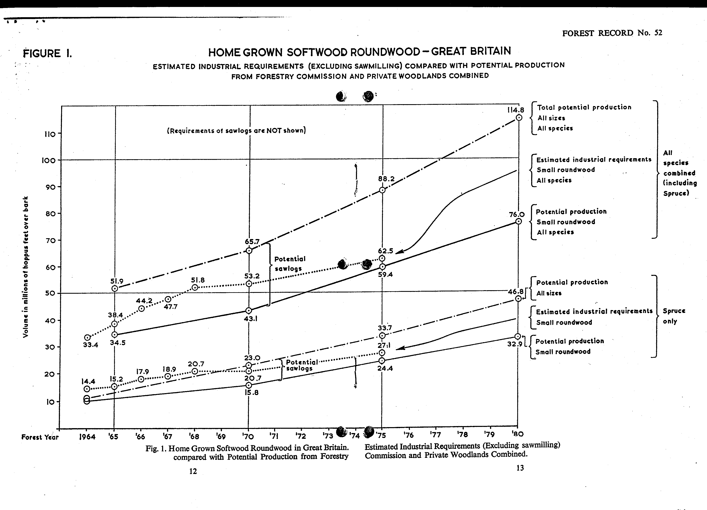
FOREST RECORD No. 52

Appendix I
ESTIMATE OF POTENTIAL PRODUCTION OF SOFTWOODS IN GREAT BRITAIN – SPRUCE AND OTHER SPECIES, IN FOREST YEARS 1965-1980.
THINNING AND FELLING COMBINED
Forestry Commission and Private Woodlands combined and separately, divided into small roundwood and sawlogs. A sawlog
for the purpose of this table is taken as having a minimum top diameter of 8 inches over bark and a minimum length of 10 feet.

Forest Year | Country or Region | Forestry Commission & Private Woodland |  |  |  |  |  |  |  |  | Forestry Commission Only |  |  |  |  |  |  |  |  | Private Woodland Only
Forest Year | Country or Region |  |  | Small Roundwood |  |  | Sawlogs |  |  |  |  |  | Small Roundwood |  |  | Sawlogs |  |  |  |  |  | Small Roundwood |  |  | Sawlogs
Forest Year | Country or Region | Total | Total |  | Spruces | Other |  | Total | Spruces | Other | Total | Total |  | Spruces | Other |  | Total | Spruces | Other | Total | Total |  | Spruces | Other |  | Total | Spruces | Other
1965 | G.B. | 51.9 | 34.5 |  | 11.1 | 23.4 |  | 17.4 | 4.1 | 13.3 | 22.9 | 18.6 |  | 8.1 | 10.5 |  | 4.3 | 1.6 | 2.7 | 29.0 | 15.9 |  | 3.0 | 12.9 |  | 13.1 | 2.5 | 10.6
1965 | Scotland | 25.4 | 15.5 |  | 6.0 | 9.5 |  | 10.0 | 2.6 | 7.4 | 9.2 | 7.3 |  | 4.3 | 2.9 |  | 1.9 | 0.9 | 1.0 | 16.3 | 8.2 |  | 1.6 | 6.6 |  | 8.1 | 1.6 | 6.4
1965 | England | 19.6 | 13.7 |  | 2.7 | 11. |  | 5.9 | 1.0 | 4.9 | 8.4 | 7.0 |  | 1.6 | 5.3 |  | 1.4 | 0.3 | 1.1 | 11.2 | 6.8 |  | 1.1 | 5.7 |  | 4.5 | 0.7 | 3.7
1965 | Wales | 6.9 | 5.3 |  | 2.4 | 2.9 |  | 1.6 | 0.6 | 1.0 | 5.4 | 4.4 |  | 2.1 | 2.3 |  | 1.0 | 0.4 | 0.6 | 1.5 | 0.9 |  | 0.3 | 0.6 |  | 0.5 | 0.2 | 0.4
1965 | England & Wales | 26.5 | 19.0 |  | 5.1 | 13.9 |  | 7.5 | 1.6 | 5.9 | 13.8 | 11.4 |  | 3.7 | 7.6 |  | 2.4 | 0.7 | 1.7 | 12.7 | 7.7 |  | 1.4 | 6.3 |  | 5.0 | 0.9 | 4.1
1970 | G.B. | 65.7 | 43.1 |  | 15.8 | 27.4 |  | 22.6 | 6.2 | 16.4 | 33.1 | 25.5 |  | 12.4 | 13.1 |  | 7.6 | 3.3 | 4.3 | 32.6 | 17.6 |  | 3.3 | 14.3 |  | 15.0 | 2.9 | 12.1
1970 | Scotland | 31.3 | 19.2 |  | 8.4 | 10.8 |  | 12.1 | 3.7 | 8.4 | 13.3 | 10.2 |  | 6.6 | 3.6 |  | 3.1 | 1.9 | 1.3 | 17.9 | 9.0 |  | 1.8 | 7.2 |  | 8.9 | 1.8 | 7.1
1970 | England | 25.1 | 16.8 |  | 3.8 | 13.0 |  | 8.2 | 1.6 | 6.7 | 12.2 | 9.3 |  | 2.6 | 6.7 |  | 2.9 | 0.7 | 2.2 | 12.9 | 7.5 |  | 1.2 | 6.3 |  | 5.3 | 0.9 | 4.5
1970 | Wales | 9.4 | 7.1 |  | 3.6 | 3.6 |  | 2.3 | 0.9 | 1.4 | 7.7 | 6.1 |  | 3.2 | 2.8 |  | 1.6 | 0.7 | 0.9 | 1.7 | 1.0 |  | 0.3 | 0.7 |  | 0.7 | 0.2 | 0.5
1970 | England & Wales | 34.5 | 23.9 |  | 7.4 | 16.6 |  | 10.5 | 2.5 | 8.1 | 19.9 | 15.4 |  | 5.8 | 9.5 |  | 4.5 | 1.4 | 3.1 | 14.6 | 8.5 |  | 1.5 | 7.0 |  | 6.0 | 1.1 | 5.0
1975 | G.B. | 88.2 | 59.1 |  | 24.4 | 34.7 |  | 29.1 | 9.3 | 19.8 | 50.1 | 37.7 |  | 20.3 | 17.3 |  | 12.5 | 6.1 | 6.4 | 38.0 | 21.4 |  | 4.1 | 17.3 |  | 16.6 | 3.2 | 13.4
1975 | Scotland | 41.7 | 26.9 |  | 12.9 | 14.0 |  | 14.8 | 5.3 | 9.6 | 21.6 | 16.1 |  | 10.7 | 5.4 |  | 5.5 | 3.4 | 2.1 | 20.1 | 10.7 |  | 2.2 | 8.6 |  | .3 | 1.9 | 7.5
1975 | England | 32.3 | 21.7 |  | 5.7 | 15.9 |  | 10.7 | 2.4 | 8.3 | 16.7 | 12.4 |  | 4.3 | 8.1 |  | 4.3 | 1.4 | 2.9 | 15.7 | 9.3 |  | 1.5 | 7.8 |  | 6.4 | 1.0 | 5.4
1975 | Wales | 14.1 | 10.5 |  | 5.7 | 4.8 |  | 3.6 | 1.6 | 2.0 | 11.8 | 9.1 |  | 5.3 | 3.8 |  | 2.7 | 1.4 | 1.4 | 2.3 | 1.4 |  | 0.4 | 1.0 |  | 0.9 | 0.3 | 0.6
1975 | England & Wales | 46.4 | 32.2 |  | 11.4 | 20.7 |  | 14.3 | 4.0 | 10.3 | 28.5 | 21.5 |  | 9.6 | 11.9 |  | 7.0 | 2.8 | 4.3 | 18.0 | 10.7 |  | 1.9 | 8.8 |  | 7.3 | 1.3 | 6.0
1980 | G.B. | 114.8 | 76.0 |  | 32.9 | 43.0 |  | 38.8 | 13.9 | 24.9 | 71.8 | 51.1 |  | 28.2 | 22.9 |  | 20.8 | 10.5 | 10.3 | 42.9 | 24.9 |  | 4.7 | 20.2 |  | 18.1 | 3.4 | 14.6
1980 | Scotland | 55.2 | 35.8 |  | 17.6 | 18.3 |  | 19.3 | 7.9 | 11.4 | 33.2 | 23.5 |  | 15.1 | 8.4 |  | 9.7 | 6.0 | 3.7 | 22.0 | 12.3 |  | 2.5 | 9.9 |  | 9.7 | 1.9 | 7.7
1980 | England | 39.8 | 26.4 |  | 7.4 | 19.0 |  | 13.4 | 3.1 | 10.3 | 21.6 | 15.5 |  | 5.7 | 9.8 |  | 6.1 | 1.9 | 4.2 | 18.3 | 10.9 |  | 1.7 | 9.2 |  | 7.4 | 1.2 | 6.2
1980 | Wales | 19.8 | 13.8 |  | 8.0 | 5.8 |  | 6.1 | 3.0 | 3.1 | 17.1 | 12.1 |  | 7.4 | 4.6 |  | 5.0 | 2.6 | 2.4 | 2.7 | 1.7 |  | 0.5 | 1.2 |  | 1.0 | 0.3 | 0.7
1980 | England & Wales | 59.6 | 40.2 |  | 15.4 | 24.8 |  | 19.5 | 6.1 | 13.4 | 38.7 | 27.6 |  | 13.1 | 14.4 |  | 11.1 | 4.5 | 6.6 | 21.0 | 12.6 |  | 2.2 | 10.4 |  | 8.4 | 1.5 | 6.9

Note The few apparent discrepancies in the figures are due to rounding to the nearest hundred thousand hoppus feet.
FOREST RECORD No. 52

Appendix II
ESTIMATED INDUSTRIAL REQUIREMENTS (EXCLUDING SAWMILLS) OF SMALL ROUNDWOOD, SOFTWOOD ONLY, FROM FORESTRY COMMISSION AND PRIVATE WOODLANDS IN GREAT BRITAIN IN FOREST YEARS 1965-1975
“Small” roundwood is considered in this table as roundwood down to 3 inches top diameter over bark excluding potential sawlogs of 8 inches minimum top diameter over bark and 10 feet minimum length. It should be noted that pulpmills use some roundwood above this minimum size and some sawmills use logs below this minimum size.
Type of Industry | Forest Year 1964 |  | Forest Year 1965 |  |  |  | Forest Year 1966 |  | Forest Year 1967 |  | Forest Year 1968 |  |  | Forest Year 1970 |  | Forest Year 1975
Type of Industry | Total | Of which spruce | Total |  | Of which spruce |  | Total | Of which spruce | Total | Of which spruce | Total |  | Of which spruce | Total | Of which spruce | Total | Of which spruce
Coal Mines | 15.5 | 5.2 | 16.8 | 5.0 |  | 17.3 |  | 4.5 | 17.8 | 4.0 | 18.3 | 4.0 |  | 19.2 | 4.0 | 15.0 | 2.0
Pulp | 8.7 | 7.9 | 10.4 | 9.1 |  | 14.4 |  | 11.7 | 17.4 | 13.2 | 19.9 | 14.8 |  | 19.9 | 14.8 | 29.5 | 22.4
Wood Chipboard | 2.2 | 1.0 | 3.4 | 0.8 |  | 4.7 |  | 1.4 | 4.7 | 1.4 | 5.7 | 1.6 |  | 6.2 | 1.6 | 9.0 | 2.0
Fibreboard | 1.6 | 0.1 | 2.4 | 0.1 |  | 2.4 |  | 0.1 | 2.4 | 0.1 | 2.4 | 0.1 |  | 2.4 | 0.1 | 3.0 | 0.1
Woodwool | 0.4 | 0.2 | 0.4 | 0.2 |  | 0.4 |  | 0.2 | 0.4 | 0.2 | 0.5 | 0.2 |  | 0.5 | 0.2 | 1.0 | 0.3
Fencing | 5.0 | - | 5.0 | - |  | 5.0 |  | - | 5.0 | - | 5.0 | - |  | 5.0 | - | 5.0 | 0.3
GRAND TOTAL | 33.4 | 14.4 | 38.4 | 15.2 |  | 44.2 |  | 17.9 | 47.7 | 18.9 | 51.8 | 20.7 |  | 53.2 | 20.7 | 62.5 | 27.1

Notes
- The volume figures shown on this table make no allowance for conversion waste which might be incurred in preparing roundwood to the various specifications required industrially. Physical waste, which results from preparing wood to one specification, can often be used in preparing another.
- Coal Mines: The following points should be borne in mind:-
- In 1962 the National Coal Board is estimated to have used as round pitwood plus sawn mining timber the equivalent of 15 to 16 million hoppus feet over bark of home grown softwood of sizes which would be almost entirely within the definition of “small roundwood” used in this table. Practically the whole of the Board’s requirements in Scotland are supplied by Scottish forests.
- The National Coal Board intends to use increasing quantities of home grown softwood if these are available on acceptable terms. The estimates of totals – up to 1970 are base on guidance given by the Board. The 1975 figures are author’s estimates and so are the figures for spruce.
- Fencing: It is not known how much “small roundwood” softwood is used for fencing; the figure of … million hoppus feet is a rough estimate. Not all of this volume would be derived from material of … inches top diameter over bark and up: some would be of a smaller diameter.
- Sources: The figures used in this table are not based on officially published sources. They are estimates based on many different sources.
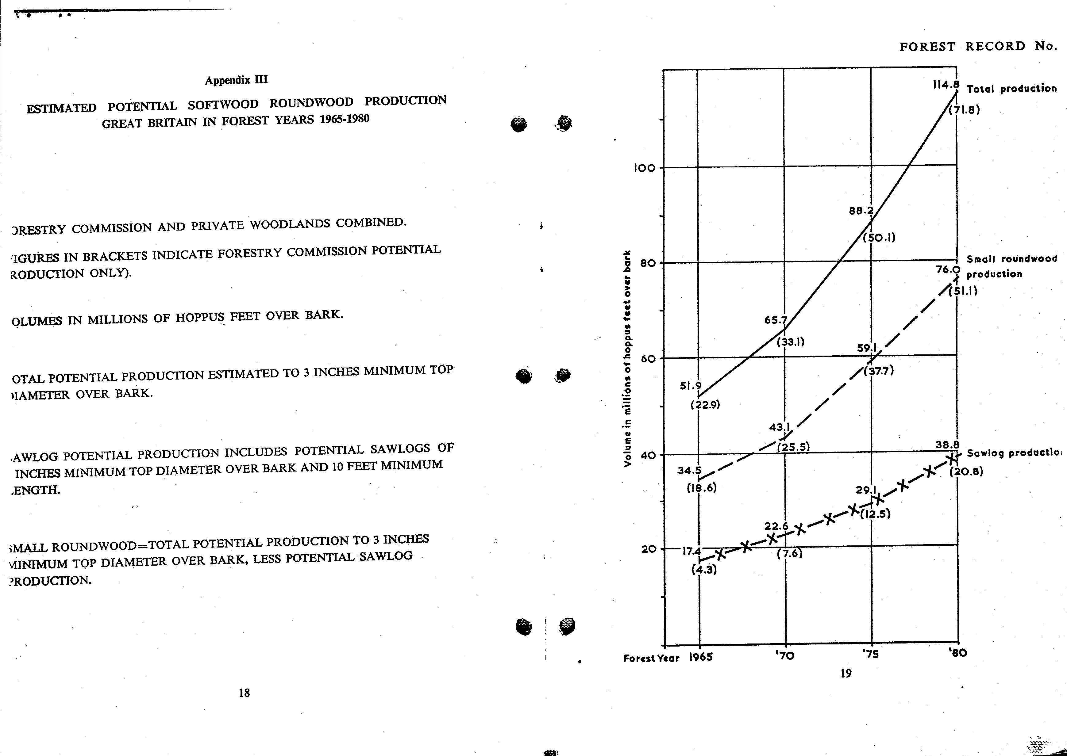

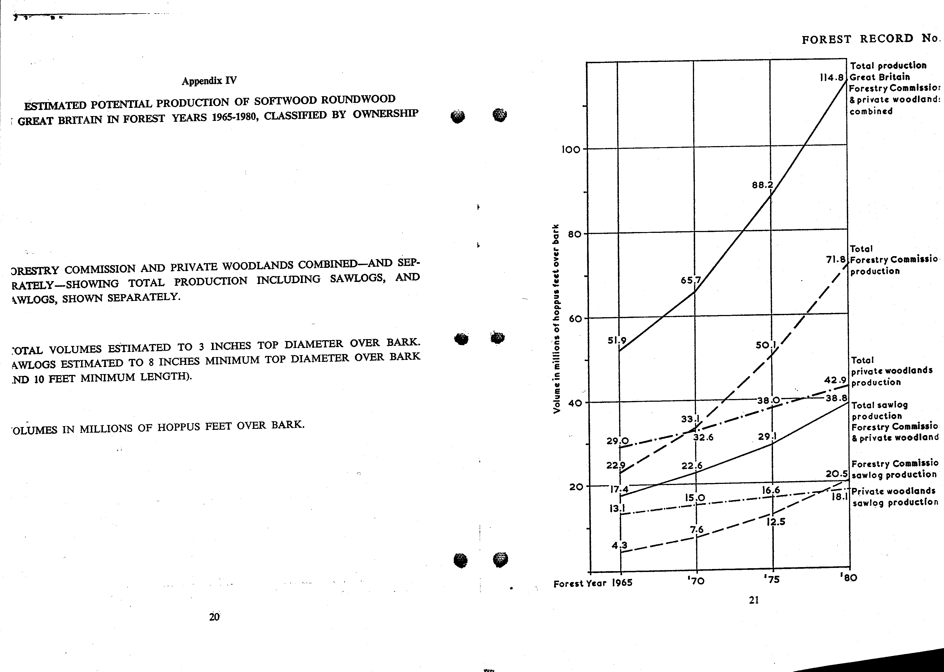
FOREST RECORD No. 52

Appendix V
ESTIMATED POTENTIAL PRODUCTION OF HARDWOODS IN GREAT BRITAIN BY FORESTRY COMMISSION (FC),
PRIVATE WOODLANDS (PW), AND COMBINED
 | Forest Year 1963 |  |  |  |  |  |  | Forest Year 1965 |  |  |  |  |  |  | Forest Year 1970 |  |  |  |  |  |  |  |  |  | Forest Year 1970 |  |  |  |  |  |  | Forest Year 1980
 | Felling |  | Thinning |  | Totals |  |  | Felling |  | Thinning |  | Totals |  |  | Felling |  |  | Thinning |  |  | Totals |  |  |  | Felling |  | Thinning |  | Totals |  |  | Felling |  | Thinning |  | Totals
 | FC | PW | FC | PW | FC | PW | T | FC | PW | FC | PW | FC | PW | T |  | FC | PW | FC | PW |  | FC |  | PW | T | FC | PW | FC | PW | FC | PW | T | FC | PW | FC | PW | FC | PW | T
ENGLAND & WALES | 1.5 | 30.4 | 0.7 | 6.0 | 2.2 | 36.4 | 38.6 | 1.5 | 29.9 | 0.8 | 5.9 | 2.3 | 35.8 | 38.1 |  | 1.4 | 29.0 | 0.8 |  | 5.6 |  | 2.2 | 34.6 | 36.8 | 0.9 | 29.3 | 1.0 | 5.4 | 1.9 | 33.7 | 35.6 | 0.8 | 27.5 | 1.3 | 5.3 | 2.1 | 32.8 | 34.5
SCOTLAND | - | 6.6 | - | 1.1 | - | 7.7 | 7.7 | - | 6.4 | - | 1.0 | - | 7.4 | 7.4 |  | - | 5.9 | - |  | 0.8 |  | - | 6.7 | 6.7 | - | 5.4 | - | 0.8 | - | 6.2 | 6.2 | - | 4.9 | - | 0.7 | - | 5.6 | 5.5
GREAT BRITAIN | 1.5 | 37.0 | 0.7 | 7.1 | 2.2 | 44.1 | 46.3 | 1.5 | 36.3 | 0.8 | 6.9 | 2.3 | 43.2 | 45.5 |  | 1.4 | 34.9 | 0.8 |  | 6.4 |  | 2.2 | 41.3 | 43.5 | 0.9 | 33.7 | 1.0 | 6.2 | 1.9 | 39.9 | 41.8 | 0.8 | 32.4 | 1.3 | 6.0 | 2.1 | 38.4 | 40.0

Notes
- Private Woodland’s data from unpublished forecasts – (allowance made for the yield from felling hedger.. timber –England 8 million, Wales 0.6 million and Scotland 0.6 million hoppus feet o.b.).
- Potential production could be increased to a total of, say, 50 million hoppus feet and sustained at this level for many years, by increased felling especially of mature and over mature forests, if market conditions were sufficiently attractive.

Appendix VI
HOME GROWN HARDWOODS: ESTIMATED INDUSTRIAL REQUIREMETS OF HARDWOOD FROM PRIVATE WOODLANDS IN GREAT BRITAIN AND FROM THE FORESTRY COMMISSION, EXPRESSED AS ROUNDWOOD EQUIVALENT
(Millions of hoppus feet over bark).
Year  (1) | For conversion to sawn timber  (excluding mining timber) (2) | For conversion to sawn mining timber, “apparent” requirement (3) | For other purposes (mainly pulp)  (4) | “Apparent” Total  (5)
1960 | 23.2 | 18.8 | 6.0 | 48.1
1965 | 20.0 | 16.8 | 7.0 | 43.8
1970 | 20.0 | 14.4 15.0 ? | 7.5 (could be 1.5 x or 2 x this) | 41.9 (could be 50.0)
1975 | 20.0 | 12.0 | 12.0 | 44.0 (could be 50.0)

Notes
Much sawn timber is made from the 40% waste in conversion which has been taken into account in arriving at figures for column (2) and the roundwood requirements as shown in column (3) for conversion to sawn mining timber are certainly less than the actual requirements would be if all sawn mining timber had to be produced primary sawing of roundwood.

