Scoping Study:
Conversion of woodland from non-native to native tree species
Attitudes of woodland
managers in Britain

Nadia Barsoum
Laura Henderson

January 2014

Forest Research is the Research Agency of the Forestry Commission and is the leading UK organisation engaged in forestry and tree related research. The Agency aims to support and enhance forestry and its role in sustainable development by providing innovative, high quality scientific research, technical support and consultancy services.

Contents

Introduction 4
Aims and Objectives 4
Methodology 5
Short On-line questionnaire 5
Long questionnaire ………………………………………………………………………………….. 6
Results……………………………………………………………………………………… 6
Short On-line questionnaire 7
Long questionnaire ……………………………………………………………………………… 12

Discussion………………………………………………………………………………… 18

Recommendations……………………………………………………………………… 21

References……………………………………………………………………………… 23

Appendix A – List of questions posed in questionnaires…………………………24

List of Figures

Figure 1: Short questionnaire: priority given to specified management objectives ……………………………………………………………………………………………………….. 8
Figure 2: Short questionnaire: Percentage of non native woodland to be converted to native species…………………………………………………………………………… 8
Figure 3: Short questionnaire: Reasons for converting to native species….. 9
Figure 4: Short questionnaire: Drivers for non conversion of non
native species…………………………………………………………………………………………………. 10

List of Tables

Table 1: Short questionnaire: Restocking methods…………………………………….. 11
Table 2: Long questionnaire: Principal tree species in non-native blocks….. 12

Introduction
The practices of diversifying forest stands and converting non-native conifer plantations to native woodland are frequently promoted in forestry policy. Numerous benefits are associated with these practices, including an enhanced resilience of woodlands to environmental change, improved habitat for wildlife and an increase in the aesthetic appeal of woodlands, making them more attractive spaces for public recreation. The conversion and/or diversification of forest stands is not necessarily favoured by all forest managers, however, particularly where these practices do not match well with forest management objectives or are difficult to achieve.

Little is currently known about the extent of conversion taking place in Britain – especially of conifer sites on low-grade agricultural land (as opposed to former ancient woodland sites - PAWS). Little is also known of how conversion is achieved and if anticipated benefits are accrued. In order to provide clear advice to foresters it is therefore necessary to gain a better understanding of the extent of conversion currently taking place, why and how this is achieved and what are the limiting factors where it is not being practiced.

Aims and Objectives
This report presents the results of a scoping study designed to establish some of prevailing attitudes of woodland owners/managers to conversion from non-native to native tree species in Britain. It presents the results of two questionnaires that were posed to forest managers to gain their perspectives on the following:

- Which non-native woodlands should we convert to native tree species?
- What non-native tree species do they contain and what native tree species should we convert to?
- What are the barriers to conversion?
- Which approaches have been adopted and which will give the best results?
- What are the realistic benefits/expected outcomes?
- Is full or partial conversion the objective?
The answers will contribute to an understanding of the extent of conversion, its benefits and challenges. This information could provide initial guidance on the most useful material to include in a research note or practice guide on conversion. As this report is the result of a scoping study it presents an overview of responses to date and does not necessarily represent all of the attitudes or opinions that could be gathered on this subject. It is hoped, however, that the opinions represented here provide a broad cross section of attitudes in Britain that could help to direct future research.

Methodology

Two questionnaires were devised in consultation with project partners. These included a short online questionnaire and a longer questionnaire formulated for a semi-structured telephone or face-to-face interview. The questions contained in the questionnaires were designed to capture: 1) a basic description of woodlands managed by respondents; 2) the woodland management objectives; 3) the reasons behind conversion or non-conversion and 4) the principal restocking and woodland management methods.

1. Short on-line questionnaire
The first questionnaire was brief, comprising 8 questions (see Appendix A), offering mostly multiple choice answers. This was made available on the internet with an online survey facility, Survey Monkey, (www.surveymonkey.com) as a means of reaching a maximum number of potential respondents. The link was disseminated to a variety of groups as follows:

- Mid January 2013 – Posted in the Institute of Chartered Foresters (ICF) online newsletter and ConFor online newsletter.
- End April – beginning of May 2014. Disseminated by the following organisations by e-mails, newsletters, web pages etc:

- Royal Forestry Society
- Scottish Land and Estates
- RSPB
- Forest Policy Group
- Small Woodland Owners Group
- Scottish Woodlands (Land agents)
- Robin Dixon (Scottish Land agent)

Respondents could choose to complete the questions anonymously and were given no time constraint.

2. Long questionnaire – Semi-structured Phone Interview

The longer questionnaire, comprising 20 questions, was designed to form a semi-structured telephone or face-to face-interview. A full list of questions contained in the survey is detailed in Appendix A. Suitable respondents were sourced from colleagues at Forest Research and the Forestry Commission, from professional organisations such as ConFor and from directories of forest/land managers. They comprised representatives from land owners, managing agents, the Forestry Commission and professional bodies. Some further participants were suggested by respondents themselves. Participants were sought from all areas of Great Britain, from the public and private sector. No constraint was put on the selection of participants according to the size of woodlands managed or woodland management objectives.

For this scoping study telephone interviews only took place and in order to keep the call duration manageable for the respondents, some questions were simplified or omitted depending on time available, relevancy to the individual and willingness of the participant. This was judged on a case by case basis with certain questions always given priority. The interviews varied in length from approximately 20 to 60 minutes. All answers and comments were transcribed during the call by the interviewee.

Results

Due to the differing nature of the two questionnaires, the results are being presented separately with linking comments where appropriate. As the short questionnaire included multiple choice elements, it is possible to produce quantitative results. The short questionnaire also provided answers from small woodland owners not targeted for the telephone interviews.

1. Short on-line questionnaire
In total there were 36 responses. 16 of the respondents answered all of the questions, while the majority of the remainder answered 6 or 7 of the 8 questions. Three months after advertising the link through the ConFor and ICF newsletters only 2 people had completed the survey. This disappointing uptake precipitated contact with other organisations but voluntary completion of the survey was low.

1.1 Woodland Description
Respondents came from all countries in Great Britain and were responsible for woodlands or estates of various sizes, ranging from 1.62 to 80,000 ha. 10 respondents were responsible for woodland ≤ 10 ha. Woodlands were on public or private land.

1.2 Management objectives
Nine of the ten respondents responsible for woodland ≤ 10 ha specified conservation or recreation as the principal management objective. Of the managers of medium and large woodlands or estates (20 ha – 80,000 ha), 8 had a top management objective of timber and 14 of conservation – the other answer options (agroforestry, carbon sequestration, game birds, recreation) did not feature as a top management priority for any of these woods – although they may have been important secondary objectives.

As the majority of the respondents had primary objectives of timber production or conservation, results of the questionnaire have, where possible, been split into three categories : all respondents together; ‘timber’ (only respondents with timber as the primary management objective) and ‘conservation’ (only respondents with conservation/biodiversity as the primary management objective). This allows easy distinction between the responses of managers with differing objectives. A summary of the management objectives can be found in Figure 1, considering the 32 respondents who answered this question.

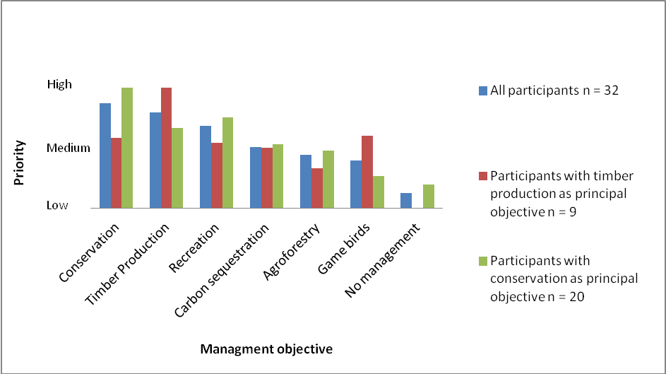

Figure 1. Priority given to specified management objectives. Respondents could select more than one objective by scoring each option according to its priority level. The final priority rating is a mean of the scores for each management objective.

1.3 Conversion Practice
Participants were asked to estimate the percentage of their non-native woods that had, or would be, converted. For those with a conservation objective, the answers ranged from 0 – 100% but the figures dropped to 1- 50% when timber was the primary purpose of management. Means of these results are displayed in Figure 2 but it should be noted that the range of answers were large. However, results suggest, unsurprisingly, that managers with a timber priority are likely to be converting less woodland to native species than those with primarily conservation-based priorities.

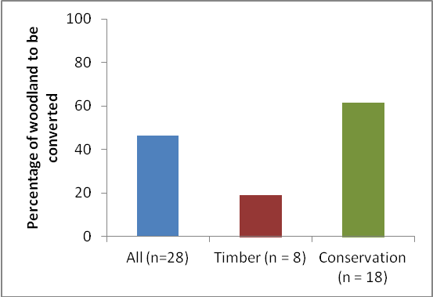

Figure 2. Mean percentage of non-native woodland that had or would be converted to native species

Respondents were asked to prioritise their reasons for practising any conversion from non-native to native species. Overall the principal driver for conversion was conservation, although resilience was marginally more important for timber foresters. However, this was based on only 8 respondents. Grant incentives were notably more important as a driver of conversion for the timber foresters than for those with a primary conservation objective (Figure 3).

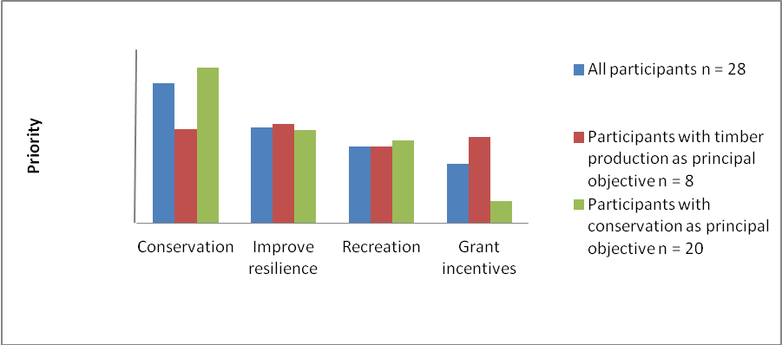
Medium
Low
High
Figure 3. Reasons for converting to native species

Respondents were also asked to select any reasons for not converting areas of non-native woodland. Over 70% of all respondents indicated conversion was outside their management objectives. Soil quality was a limiting factor for timber producers but less so for conservation foresters (Figure 4). Other options given were that conversion was too expensive, there was insufficient evidence of benefits or that there was a lack of adequate guidance.

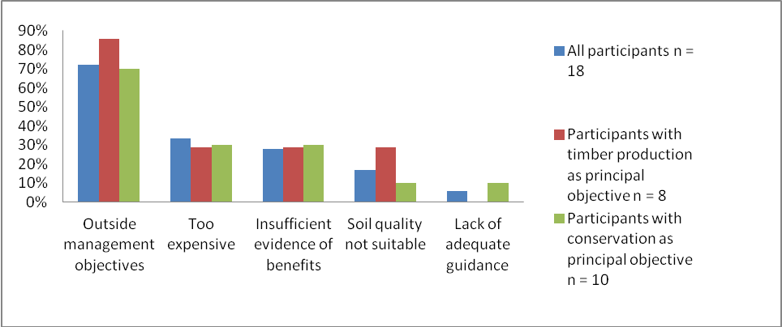

Figure 4. Percentage of respondents quoting specified reason as a driver behind non conversion of non-native species. Graph indicates the percentage of respondents who selected the specified reason as contributory to their decision. Multiple reasons could be selected and no weighting was given.

Respondents were given an additional opportunity to comment on reasons for not converting to native species. One referred to the need to keep larch and pine for biodiversity, but the majority referred to the need to maintain commercial timber production. The two most informative answers had similar concerns relating to converting from productive timber species as follows:

- “There is little or no point to practicing ethnic cleansing of non-native minor conifer species like Douglas fir, European Larch and Western Red Cedar when these are the highest value crops growing in our mixed woodland today alongside 23 other different trees growing happily alongside each other. We have lost elm and are beginning to lose oak and ash so why deliberately take out high value and very useable conifer timber trees when there is not a native equivalent that will produce such good quality timber.” (Small Woodland owner, England lowlands)

- “I do not actively encourage conversion to native species. I believe that where practical we should be producing timber. The conversion to native species with such high deer pressure is a waste of time as regen will not occur once the deer fence falls down with limited additional capital provided by landowners for such operations. I agree with UKWAS and all sites should be managed properly with appropriate corridors etc but the hard reality is we will have no timber to cut in Lochaber in 10 years time because of the amount of native planting and native conversion. Is this sustainable? I would argue in most cases it is not.” (Private managing agent, Scottish uplands)
1.4 Restocking method
Respondents were given a number of restocking methods and asked to specify how many hectares of land were restocked under the different regimes. Only 20 respondents completed this question and most provided their answer as a percentage of the total amount of woodland they managed, rather than providing actual area of woodland. Therefore, all answers were converted to percentages. The small sample size and the wide range of responses make it difficult to determine any trends for this question but suggest that restocking methods are site dependent. Results are summarised in Table 1.

Restock method | No of respondents using restock method (from total of 20) | Mean percentage of total woodland managed being restocked using specified method. % | Range %
A. Repeat commercial non-native conifer crop | 7 | 29.7 | 6 - 70
B. Replace broadleaf-conifer mixture with non-native conifer crop | 3 | 3.3 | 2 - 5
C. Replace non-native conifer with native broadleaf woodland | 10 | 17.9 | 2.2 - 85
D. Replace non-native conifer with native conifer woodland | 4 | 3.3 | 0.1-5
E. Replace non-native conifer with broadleaf-conifer mix OR conifer-conifer species mixture | 8 | 23 | 0.1 - 30
F. Admix native broadleaf/conifer species into non-native conifer stands/ Use non-native conifers as shelterwood for broadleaf regeneration | 4 | 54 | 3-100
G. Promote native broadleaf/conifer species in gaps created within non-native conifer forest | 11 | 17.2 | 2.5-50
H. Revert conifer-broadleaf mixture to native broadleaf/conifer woodland | 7 | 5.3 | 0.1 - 17
I.Other | 6 | 53.7 | 12-100

Table 1. Restocking methods used and percentage of whole estate restocked under specified method

2. Long Questionnaire – Semi Structured Interview

To date 15 forest managers have participated in the semi-structured phone interviews. Willingness to devote time to the study varied quite dramatically – some managers were brief and concise in their answers and others were notably more vocal, informative and happy to be further involved if required.

2.1 Woodland Description
Of the 15 telephone interviews completed for this scoping study, 9 were with private land owners/managers and 6 from the public forest estate. Respondents were from all countries in Great Britain. The amount of woodland being managed varied from 430 – 46,000 ha. All participants were managing at least some areas of non-native conifer plantation (excluding PAWS) ranging from 11 – 95% of the total area of woodland managed. For 10 of the 15 participants, the non-native only plantation accounted for 50% or more of their woodland. The sites are dominated by 6 principal species with Sitka Spruce being the most common (Table 2).

Non native tree species | Number of woodland estates (n=15) with given tree species present (and number where species is the dominant or co-dominant of all non natives)
Sitka Spruce | 10 (8)
Lodgepole Pine | 5 (2)
Corsican Pine | 4 (3)
Larch | 4 (2)
Scot’s Pine (outside its native range) | 3 (2)
Douglas Fir | 3 (0)
Others (Western Red Cedar, Norway Spruce) | 3 (0)

Table 2: Principal tree species found in blocks of the owner’s non-native woodland and the number of woodland estates with these species as dominant or co-dominant

The non-native conifer plantations are principally single-aged, with planting dates ranging from the 1930s to the 1980s. Two owners suggested that their management plans were working towards diversifying the age structure but this was not a separate question posed during the interview.
All of the participants also had some areas of native broadleaf woodland – the principal tree species were oak, ash, and birch with beech more occasional. However when asked which native tree species are retained or purchased, the list became much broader and included; juniper, cherry, rowan, hazel, aspen, whitebeam and hornbeam. This suggests that the foresters are encouraging species diversity in native woodland blocks. One participant commented that they would be happy for any species from which timber can be viably extracted and more than one commented that they would accept natural regeneration of any native tree species on these sites.

2.2 Management objectives / Conversion Practice
The managers of the public estate all specified that timber production was a major objective in their woodlands but that this had to be done with other organisational objectives in mind, principally recreation and conservation. The picture in the private sector was not dramatically different but was profoundly financially driven. Two participants had a sole objective of conservation only and two solely of timber production. The remainder had multiple objectives that could be classified under ‘maintaining capital value’ – therefore producing timber, game, recreation, education etc. Which income resource was exploited was largely site dependent. None of the managers specified carbon sequestration as an objective. While this had featured quite significantly as a secondary objective in the short survey, this is likely to have been affected by its inclusion in the multiple choice list of possible answers.

As with the short survey, respondents were asked to specify what percentage of their non-native woodlands had, or would be, converted to native species. The two managers with sole conservation objectives specified 100% and 90-95% respectively. The latter was maintaining areas of larch as it has high conservation value for black grouse. All other respondents specified values between 0 and 15% suggesting conversion rates on woodland managed for capital value is very low. This split mirrors the findings of the short online survey which also found a notable difference between conversion levels on sites managed for timber or conservation objectives. Some managers did, however, specify that their management plans were always subject to potential alteration and objectives for a stand for the following rotation cycle could change.
The most popular driver for any conversion of these woods was resilience – mostly to disease but also occasionally climate change. 7 participants drew attention to resilience as a factor and others also mentioned obligations under grant schemes, increasing productivity, site suitability and conservation. Public estate managers also mentioned landscape appearance as a factor. The majority of answers indicated an underlying concern for present and future productivity and associated economic viability. One manager said conversion was only done for increased productivity, for instance, by managing deer rides etc. Two said they would only ever convert if replanting with exotics would not be productive on the chosen site or an existing management plan was unworkable.

A couple of respondents said they were obliged to practise conversion under the terms of grants and that this could be restrictive to their overriding objectives. However, another indicated that grants could be critical if suggested practices were likely to compromise productivity. However, he also added that a truly commercial forester should not be dependent on grants which should, moreover, operate as a subsidy to kick start an environmental or social enterprise.

Reasons for not converting
Interviewees were asked to specify their primary reasons for not converting any areas of non-native species. The majority (80%) responded that conversion was not economically viable for a variety of reasons summarised below in descending order of priority:

- Site is not suitable: Many productive sites are on steep or wind-prone slopes, impoverished soils or at such a distance from seed sources that native broadleaf species are not viable or would be too expensive to establish/manage.
- Scepticism about sustainability of 100% native tree species crop: In light of the high incidence of disease in many native tree species at present, managers are often not convinced that native species offer the most sustainable future. They see diversification which includes exotic species as a better solution than straight conversion to natives.
- Productivity is compromised: PAWS sites and others earmarked for restoration are already accounting for much conversion which is regarded by many managers as compromising productivity. Managers do not want to further reduce viable timber production.
- Insufficient practical knowledge and market forces: Contractors and the market are not well set up to process native species or novel management techniques and are not likely to be so until the scale of this production increases dramatically.
- Pests: Over grazing of saplings by deer and bark stripping by squirrels make native crops non-viable.

2.3 Restocking method and management practices
The diversity of responses to questions about restocking practice, methods of ground preparation and herbivore control make it clear that the methods employed are almost entirely manager- and site-specific and can vary dramatically between and within estates. The criteria affecting these decisions depends on past practice, cost, soil and site conditions, original planting date and rotation stage, owner preference, reliability of natural regeneration, herbivore problems etc.

RESTOCKING METHODS
Many managers are maintaining clear-fell and direct planting regimes on their non-native plantations and in these cases, restocking is generally in even rows at 2,000 – 3,000 stems per hectare. Several managers did, however, specify that planting patterns are species dependent and some have variable or experimental areas with different densities. Some managers have also introduced some selective thinning, continuous cover and underplanting in certain areas. Some of the managers were trying different techniques on different sites to aid diversification, but the majority are governed by site conditions.

Natural regeneration of stands of native species is generally deemed best and cheapest although not always predictable or effective. One manager felt that local seed trees are too old to be viable and another commented that relying on natural regeneration meant you are less in control of species management. However, an alternative opinion specified it is best to work with what comes naturally and to adjust at the second thinning. In 6 cases, supplementary planting is used although additional managers who did not plan to do supplementary planting implied it is sometimes required. Several managers indicated that prolific natural regeneration of non-native species has to be managed which is time consuming and expensive. Three managers also expressed specific problems with invasive Rhododendron. Where conversion is taking place it is based on site objectives but not on the desire to remove or replace particular species unless they are diseased or under threat.

RESTOCK MATERIAL
Attitudes to restocking material varies quite dramatically. For replanting of non-native species, managers often choose stock for its form and density with some using improved stock specifically grown for these properties. Where additional planting of native species is required, some managers prefer to use nurseries that stock local provenance material whilst others are looking to diversify provenances. One manager said that much local stock is originally from elsewhere anyway. Three managers collect their own seed and propagate it themselves or contract it to nurseries.

GROUND PREPARATION
Preferred method of ground preparation is also site and species dependent. Ditch mounding and/or scarification are the two most commonly used techniques to aid establishment and drainage. Methods vary from depending on natural scarification by wild boar to disturbance created by harvesters. One manager specified that mounding was necessary so that the new planting could still be viewed above bracken encroachment. Another suggested that mounding provided some protection against weevils. All managers retain brash on site, with differing techniques for its dispersal depending, in general, on methods of ground preparation.

FERTILIZERS AND HERBICIDE USE
The two managers with a primary conservation objective both used small amounts of fertilizer when planting but no herbicides. None of the other managers use fertilizers. One suggested that if fertilizers are required you are trying to put the wrong tree on the wrong site and another said the cost/benefit did not stack up. The majority of managers use herbicides – most often to control bracken, bramble and grass.

HERBIVORE PROTECTION
Deer are a notable problem for all managers except those in Wales who instead use fencing to protect saplings from sheep. Most other managers have an extensive programme of deer culling, selective deer fencing and tree guards where necessary. Many managers commented that deer control is a considerable expense, with one manager having to employ 3 full-time stalkers. Rabbits and squirrels were also highlighted as problems.

General attitudes to conversion and additional comments

The final question of the survey gave participants the opportunity to add comments or viewpoints about conversion with no further prompting. Many drew attention to the limitations of circumstances and a lack of conviction that native species brought any tangible benefits especially commercially. They also expressed concern that too much conversion was going to compromise timber production in the long term.

Some of the comments found below help to encapsulate attitudes generally and indicate certain barriers to conversion:

“Conversion is not viable for the timber industry unless incentives for ecosystem service provision are increased” (Private estate manager, Scottish Highlands)

“I am prepared to take the necessary financial loss on conversion because my objectives are conservation based” (Conservation charity, Scotland)

“Conversion is good for managing risk and species diversification is a big push in Wales but not very many private woodland owners take it seriously. My clients are interested in grants. I believe the grant system should be removed completely as it is too constraining for good, responsive management – they are too inflexible for on the ground responses.” (Managing agent, Wales)

“We have to be very careful about reducing productive capacity – also in light of carbon sequestration. With a priority on PAWS conversion it could be risky to start converting plantations too. A lot of broadleaf is compromised by squirrels and deer – investing in it is doomed until they are under control. Broadleaves are desirably but risky” (Private Estate Manager, Lowland England)

“Non native regeneration can be very prolific and we must use our resources wisely. Money and time might be better spent planting new woodland than fighting natural regeneration of non native species.” (Conservation charity, Scottish Highlands)

“Conversion is likely to compromise timber production and the Forestry Commission need to be careful as so much of their income is dependent on it. With mixed objectives we have to look at sites individually – sometimes conversion is advisable sometimes not.” (Forestry Commission District Forester, England)

“We need to get away from prescriptive ways of management and allow proper site-specific silviculture back. We used to be able to do sensitive thinning programmes but contractors are now too big and machinery too large so contractors are calling the shots.” (Forestry Commission District Forester, Scotland)

“Scale is critical to develop the market in new species – contractors won’t pay for new machinery unless the crop is large…compromising productivity also compromises local economy and a whole chain of events” (Forestry Commission Operations Manager, England)

“Generally farmers have less clear objectives [than foresters] as they are reluctant to manage their woods. However they tend to want diversity and they are often good at exploiting niche markets for wood products” (Managing agent, Wales)

Discussion

The surveys conducted for this study suggest that attitudes to conversion are the result of different approaches which arise from differing management objectives: principally commercial production or conservation. Although this does not suggest that there is a fundamental split between managers as many have multiple objectives, the divide has also been acknowledged in other recent research on landowner attitudes to woodland management (Lawrence and Marzano 2013). Responses to the questionnaires of this scoping study suggest the following answers to the research questions:

IN THE OPINION OF FOREST MANAGERS WHICH FORESTS SHOULD BE CONVERTED?

When attempting to identify which forests should be converted, the answers provided for this study would suggest any combination of three principal criteria:

- forests that are possible to convert on the basis of site conditions and species suitability
- those that can be converted with no loss of productivity or revenue
- those for which conversion will afford greater future resilience than other species choices
The species composition of the existing woods did not seem of concern except where threatened by disease. Biodiversity value was not often a stated concern of managers with commercial objectives but for managers with conservation in mind conversion was desirable wherever the benefits to biodiversity were likely to be tangible.

Forest sites suitable for conversion will still always be governed by their owner’s objectives. Although not a separate query in the questionnaire the discussions with land owners suggest that personal preference, knowledge of existing species under management and experience are also likely to influence land owner’s propensity to convert.

WHAT ARE BARRIERS TO CONVERSION?

The principal challenges to conversion are both theoretical and practical. Many managers do not perceive evidence of the benefits and many are further restricted by economic and practical constraints. Responses from the questionnaires indicate that where land is managed for commercial reasons the levels of conversion from non-native species to native is low due to concerns over productivity and revenue loss. By contrast managers with a principal objective of conservation are favouring conversion even if there is an economic cost.

Site conditions are a primary constraint in the determination of woodland management plans. Many of the non-native plantations are on poor quality sites which preclude certain species – particularly native broadleaves. These conditions, combined with the need to be commercially successful, often result in a limited species choice.

Market conditions and contractor capabilities were also specified as challenges to conversion. Certain respondents, however, expressed belief that market and management systems were entrenched in traditions that were gradually changing. A greater evidence base that native species and their associated silvicultural requirements are commercially viable could encourage industry-wide changes. It was acknowledged that producing management plans for large-scale native timber production was also challenging as it is harder to predict outcomes and timings than with existing non-native rotations. This, combined with the need for clear targets for timber output, could also create a barrier.

WHAT ARE THE BEST METHODS OF CONVERSION AND THE LIKELY BENEFITS?

Methods of conversion, where it has been practiced, vary almost entirely on the basis of site conditions including soil, aspect, slope, seed tree availability, water availability, wind risk and access. The species to be converted also affect recommended methods but in general favour is given to mixed planting over single species. Most managers prefer natural regeneration where possible but significant limitations to success include pressure from deer and squirrels, availability of viable seed trees and unwanted regeneration of non-native species. Deer control in England and Scotland is paramount to success.

Where additional planting is required the preferred source of stock varies from that collected and propagated on site through to nursery stock from southerly provenances. There was little consensus on this with responses being quite personal to the land manager in question.

Fertilizer use is minimal but herbicides may be required against competitive grasses or bracken/bramble encroachment. Ground preparation is site dependant but scarification and/or mounding are the most commonly used methods to aid with establishment. Brash retention is universally practiced.

Managers with conservation aims identified the greatest benefits associated with conversion however even in these cases retention of some non natives is considered beneficial for certain species. For commercial foresters benefits of conversion are not widely recognised. Resilience to disease is the primary benefit specified but others suggest that grant contributions and enhanced productivity in certain very limited cases could be beneficial.

SHOULD COMPLETE CONVERSION STILL BE THE AIM?

Attitudes to future management indicate that there is more concern for diversity overall i.e. including exotic species than in ‘naturalness’ per se. Many managers appear to associate the concept of conversion with that of diversifying in general as they prioritise the need to diversify over the need to convert. Therefore if they are converting to any native species it is often as part of a diversification plan that also includes increasing the number of non-native tree species. The overriding objective in these cases is resilience to disease.

Some managers with a conservation concern also acknowledge certain benefits associated with non-native species. Responses from these questionnaires indicate that conversion may be more likely if included in a general scheme of diversification and admixture for resilience than a blanket change to native species.

Concern over timber productivity and market possibilities also suggest that managers do not believe a total switch to native species is viable but that admixing could enable changes in systems/market to be gradual and adaptive.

Recommendations

The responses obtained in this study help to identify some areas requiring additional research. They suggest that future guidance to managers on conversion practices would need to address the following issues/challenges:

- Evidence for the potential for comparable productivity or revenue produced by native species
- Evidence base of the tangible benefits for biodiversity
- Site conditions and species suitability – soil, aspect, access possibilities, climate - especially in light of the need for increased resilience
- Recommended methods for converting according to site and species
- Markets for native wood products and suitable contractors/saw mills
- Nurseries and restock suppliers for species of choice
- Local seed sources and potential for regeneration
- Differing levels of management required i.e potential impact of invasive species or prolific regeneration of non natives
- Risk of herbivore damage and associated prevention
- Conservation implications for species of interest/concern and those using non-native woodlands
- Management decisions: methods of flexible management planning and target setting
- Grants: restrictions and benefits
Some of these issues require more focused research which could come from a variety of sources including published literature, extended questionnaires to land managers/ industry representatives and site visits. A more targeted approach to managers with specific experience of conversion (successful or not) would be beneficial especially in a commercial context.

The questionnaires employed for this study do not provide very far reaching evidence of best approaches or site conditions for success. However, given the low amount of conversion taking place, finding suitable and willing participants could be difficult and this information may have to be supplemented with published papers such as research on regeneration potential and tree species choice (for example: Spracklen et al 2013, Harmer et al 2011, Willhoughby et al 2007 and references therein plus references contained in Nadia Barsoum’s Report on practical conversion 2012).

In light of the low levels of conversion taking place in commercial forestry and the challenges identified, guidance on benefits/methods of admixing non-native tree species with natives may be more readily received by certain managers than others.

References

Harmer, R. Morgan, G., Beauchamp, K., (2011) ‘Restocking with broadleaved species during the conversion of Tsuga heterophylla plantations to native woodland using natural regeneration’ Eur J Forest Res 130: 161-171

Lawrence, A and Marzano, M (2013) ‘Is the private forest sector adapting to climate change? A study of forest managers in north Wales’ Annals of Forest Science

Spracklen, B.D. Lane, J.V., Spracklen, D.V., Williams, N., Kunin, W.E. (2013) ‘Regeneration of native broadleaved species on clearfelled conifer plantations in upland Britain’ Forest Ecology and Management 310 204-212

Willoughby, I., Stokes, V., Poole, J., White, j., Hodge, S. (2007) ‘The potential of 44 native and non native tree species for woodland creation of a range of contrasting sites in lowland Britain’ Forestry 80: 5 531-553

Appendix A

Below are the questions that formulated the questionnaires for this study – questions in bold were those also featured in the short on line survey.

- What is the approximate area (ha) of the woodlands you manage?
- Is the woodland privately or publicly owned land?
- In which region is the woodland that you manage located?
- Approximately how many hectares of conifer-only plantation stands are present in the woods you manage? What species do they contain?
- Approximately how many hectares of broadleaf-only woodland are present in the woods you manage? What species do they contain?
- What is the age configuration of your woodland?
- What are the key management objectives of the woodlands that you manage?
- Where conversion of non-native conifer has been or is actively practiced in the woodlands that you manage, what are the key drivers?
- In approximately what % of the conifer woodlands that you manage is conversion presently (or will in future be) undertaken?
- Where conversion is not practiced, please provide the reasons why.
- What restocking schemes are you using? (Options provided for online survey can be found in table x)
- What is the principal form of regeneration of native conifer/broadleaf tree species? (e.g. direct seeding; planting; natural regeneration)?
- Where direct seeding and/or planting of trees is practiced, what is the origin of the restock material that is purchased?
- Please list the native tree species that are purchased, or that are deliberately retained following natural regeneration.
- What planting/sowing patterns do you use (e.g even spacing, uneven spacing, intimate mixtures etc)?
- What ground preparation methods do you use and why?
- Do you use fertilizers and/or herbicides?
- What and how much herbivore protection do you use?
- Is brash retained on your site if so is it spread evenly or piled?
- Do have any additional comments about conversion; suggested benefits or limitations etc?

